CASE FILE 01
Driftwave Audio
Product line: wireless earbuds
Driftwave is a Chicago startup launching its first wireless earbuds. The founders want three versions on the shelf by spring, but they can't agree on who each version is for.
Your job: Build a lineup of three versions, one for each segment below. For every version, choose its features and set its price. Your goal is the most total profit across all three.
THE MARKET: THREE SEGMENTS
Driftwave Audio surveyed people in the Chicago area. The survey split them into three groups. Read the profiles, then give each segment a name.
SEGMENT A  9,000 potential customers | SEGMENT B  14,000 potential customers | SEGMENT C  4,000 potential customers
- Ages 15 to 24, works out 4 or more times a week  - 68% have lost or broken earbuds mid-workout  - Wants a pair cheap enough to replace without crying  “If they fall out during a box jump, they're dead to me.” | - Ages 14 to 22, rides the bus or train every day  - Mostly streams music and videos  - Usually paying with their own job money or a gift card  “I just need them to last the whole school day.” | - Ages 22 to 40, takes video calls for work  - Works from home, coffee shops, and airports  - Says sound quality is the #1 reason they'd switch brands  “I'll pay more if I never hear the leaf blower outside again.”
Our name for them: | Our name for them: | Our name for them:
PRODUCT BASICS
Base cost of every version | $14 per pair, before any features are added
Price options | $29 $49 $79 $119 $159 $199 (each version must use one of these prices)
WARM-UP: READ THE DATA FIRST
1. Which segment has the most must-have features (60% or higher)? How many does it have?

2. What is the most expensive feature on the menu? Which segment, if any, says it is a must-have?

3. What is the lowest price at which fewer than half of Segment B would buy?

4. If Driftwave Audio sold a version with a Fit of 100% to Segment A at $79, how many people would buy it?

SURVEY RESULTS: WHAT EACH SEGMENT REQUIRES
Question asked: “Which of these would a wireless earbud need to have before you would buy it?”
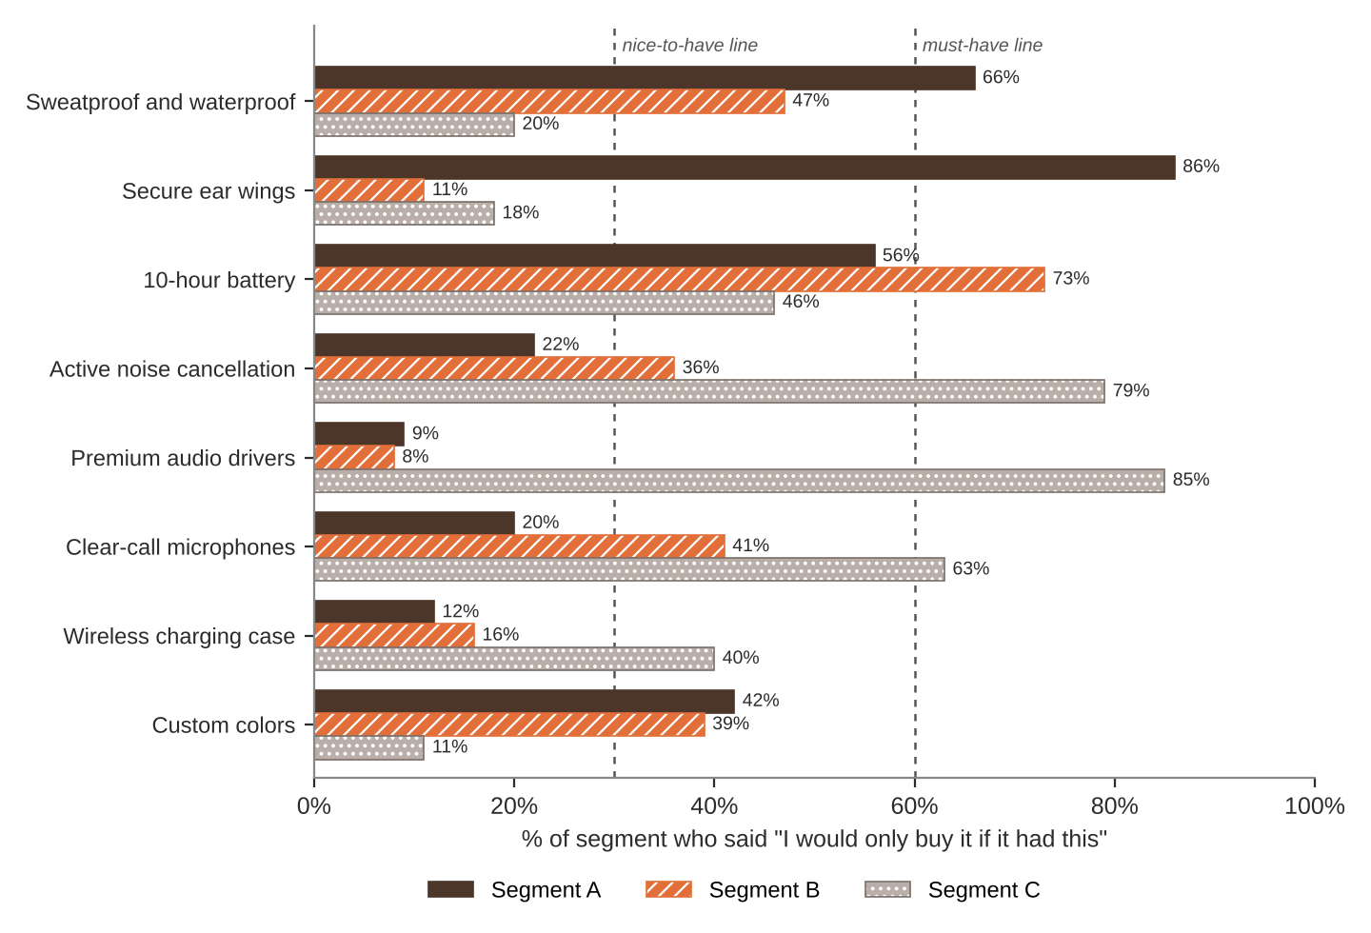
FEATURE MENU
Every feature you add raises your cost per pair. Add a feature to any version you want.
Feature | What it is | Cost to add
Sweatproof and waterproof | Survives sweat, rain, and the occasional sink | $4
Secure ear wings | Soft hooks that lock the bud in place | $2
10-hour battery | Lasts a full day without the case | $5
Active noise cancellation | Blocks out background noise | $18
Premium audio drivers | Richer bass and clearer highs | $14
Clear-call microphones | Callers hear you, not the wind | $6
Wireless charging case | Drop it on a pad to charge | $7
Custom colors | Pick from 8 colorways | $3
SURVEY RESULTS: WHAT EACH SEGMENT WILL PAY
Question asked: “If it had everything you need, would you buy it at this price?”
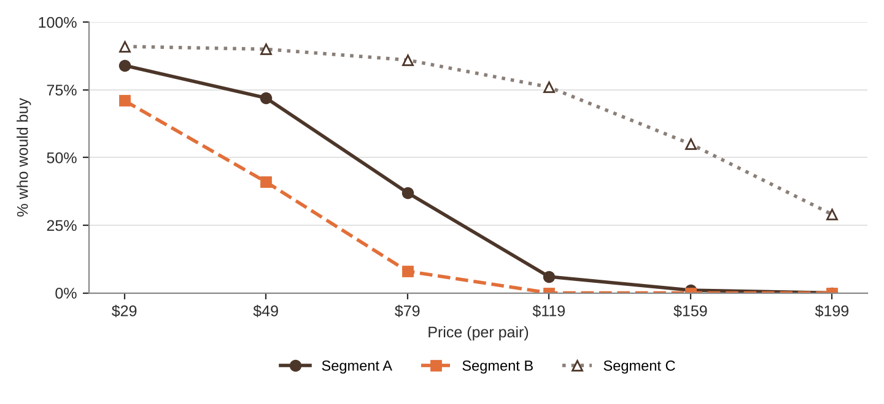
% of each segment who would buy at each price
Price | $29 | $49 | $79 | $119 | $159 | $199
Segment A | 84% | 72% | 37% | 6% | 1% | 0%
Segment B | 71% | 41% | 8% | 0% | 0% | 0%
Segment C | 91% | 90% | 86% | 76% | 55% | 29%
QUICK RULES
Must-have | A feature that 60% or more of a segment requires. Leave one out and that segment's buyers are cut in half. Leave two out and they're cut in half again.
Nice-to-have | A feature that 30% to 59% of a segment requires. Each one you include adds 5% to Fit.
Under 30% | That segment doesn't care. It adds cost and nothing else.
Fit | Start at 100%. Add 5% for each nice-to-have included. Then cut in half for each must-have left out.
Buyers | Segment size × % who would buy at your price × Fit. Round to a whole number.
Profit | Buyers × (Price − Unit cost). Unit cost = base cost + cost of every feature you added.

